How to get advising while sheltering in place
Spring 2020

COMMUNICATION STUDIES

Before you contact an advisor……..

Use the following pages to understand your
Degree Progress Report.

Log in to the SF State Gateway:

Start at your student center from “My SFSU.”
- Use the quicklink on the SF State homepage.

Use the dropdown menu, to choose
Degree Progress Report.
- Remember to press the “go” button to generate the report.

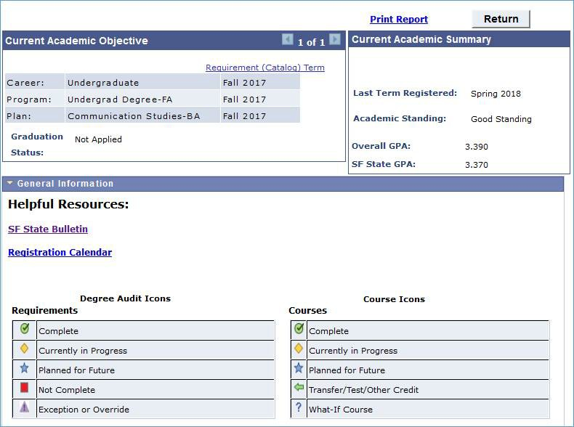Your DPR tracks your progress to degree.

Green box = You’ve satisfied this requirement.

Yellow box =
You are currently enrolled in a class that satisfies this requirement.

Red box = You still need to complete this requirement.

Click “Expand All” to make all boxes visible.

Or, click individual green
triangles to see specific
requirements.
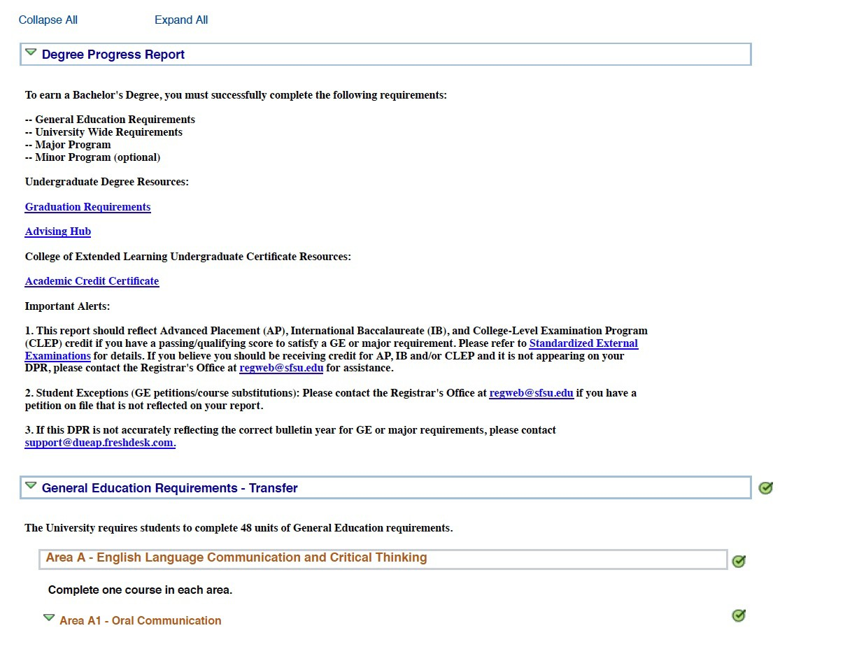

GE & other University requirements are listed first:

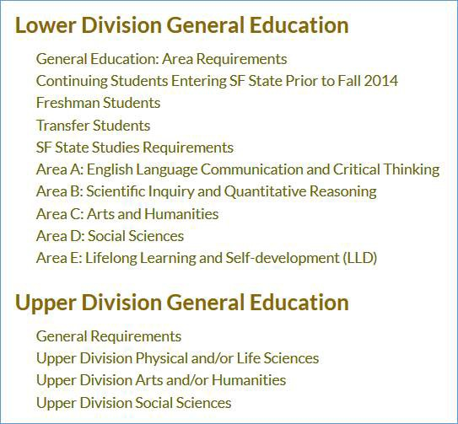There are two levels of General Education:
University requirements also include:
u History & Government
u Residence Units (including upper- division residence units).
u GPA (2.0 minimum)

u 120 units to graduate!
(note that the “Units Taken” reflect units currently in progress!)

Advising Resources

Contact the Advising Resource Center or University Advising Center about general education requirements or other non-major university requirements.

u Click the “Need to schedule an appointment” button on either site.
u https://advisinghub.sfsu.edu/
u https://advisinglca.sfsu.edu

What about Complementary Studies?

u The DPR now has an area for Complementary Studies (as of Spring 2020).
u Complementary Studies (CS) is a 12-unit graduation requirement for students declaring a Communication Studies major in Fall 2014 or later. It is meant to provide depth in another area and “complement” your major.
u Your advisor can initially approve your Complementary Studies plan
by e-mail, and can verify it to turn the box green on your DPR when you have completed the classes for this requirement.

4 ways to complete Complementary Studies

u 12 units of courses using the same or similar department prefix outside the major (for example, PSY, SOC, PLSI).
u Take a minor or certificate program (or 12 units of a minor or certificate).
u Take 12 units of study abroad.
u Take 12 units of non English language study.

Courses in Complementary Studies may be any combination of courses taken at community college and/or SFSU, and may be lower and/or upper division.

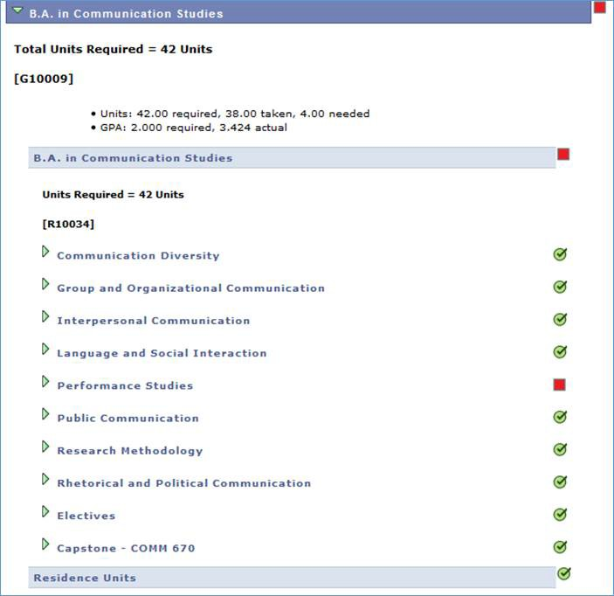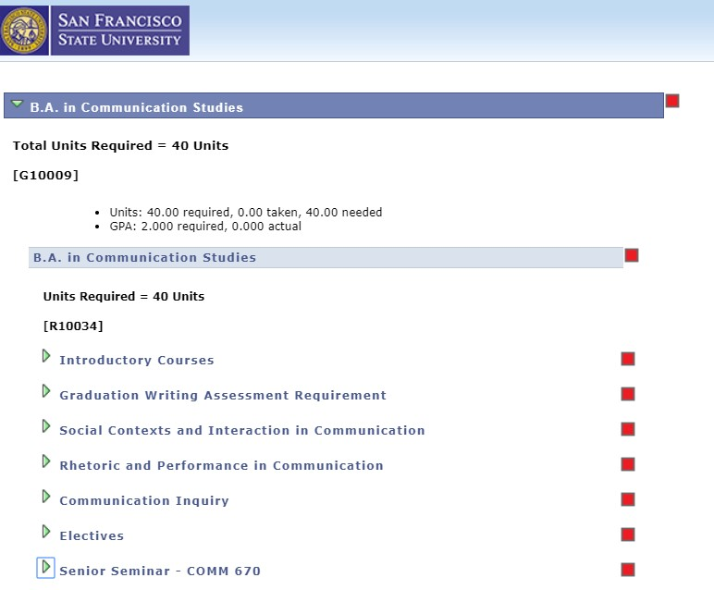

Your COMM major requirements are shown in the last section of your DPR
Your requirements depend on when you entered the major

“Current” major after SP 2017: “Old major” SP17 and earlier:

Our Major at a glance for majors entering Spring 17 or later
Lower-division COMM requirement
COMM #’s 120-299 (6 units)
COMM 150 may only count if another course can satisfy GE A1

Upper-Division COMM requirements

Graduation Writing Assessment Requirement (GWAR): 4 units COMM #300s
Choose: COMM 300 # courses with “GW”

Social Contexts & Interaction: 8 units Choose: COMM #’s 400-449 & 500-549
Note: COMM #s 400-449 are 1 & 2 units; 500-549 are 4 units.

Rhetoric & Performance: 8 units Choose: COMM #’s 450-499 & 550-600
Note: COMM #s 450-499 are 1 & 2 unit; 550-600 are 4 units.

Communication Inquiry: 4 units COMM #’s 661-664

COMM Electives: 8 units
Choose: COMM #’s 400 & 500’s, 368, 685, 695;
only 2 units can be lower division. Senior Seminar: 2 units COMM 670

Key things to remember

u Take your GWAR course in the first 8 units of your major.
u Check your total unit count. You must reach a minimum of 120 units.
u Find the full “BA planner” on the Communication Studies Department website.
u Find instructions for filling out a graduation application on the Communication Studies Department website.

Contact a department advisor with questions or to set up an appointment

Please e-mail only one advisor:

Dr. Shadee Abdi sabdi@sfsu.edu Dr. Fatima Alaoui fzalaoui@sfsu.edu
Dr. Colleen Daniher ckdaniher@sfsu.edu Dr. Constance Gordon cgordon@sfsu.edu Dr. Christopher Koenig cjkoenig@sfsu.edu Dr. Karen Lovaas klovaas@sfsu.edu
Dr. Paloma Mathern amolap@sfsu.edu Dr. Samuel McCormick mccrmck@sfsu.edu Dr. Gerianne Merrigan merrigan@sfsu.edu Dr. Joseph Tuman joetuman@sfsu.edu Dr. Leah Wingard wingard@sfsu.edu Dr. Gust Yep gyep@sfsu.edu

